**Welcome**

**Puratchi Thalaivar Dr.M.G.R.**

**GOVT.ARTS & SCIENCE COLLEGE**

**Agaram, Madhanur, Vellore Dt-635 804.**

**B.SC., (Mathematics)**

**PROJECT NAME:**

**UNVEILING MARKET INSIGHTS: ANALYSING SPENDING BEHAVIOUR AND IDENTIFYING OPPORTUNITIES FOR GROWTH.**

**TEAM LEADER NAME: ABINAYA.S**

**TEAM MEMBERS:**

1. **ABINAYA. S**
2. **BHUVANESHWARI. M**
3. **DEVAKUMAR. A**
4. **DINESH. K**

**UNVEILING MARKET INSIGHTS: ANALYSING SPENDING BEHAVIOUR**

**AND IDENTIFYING OPPORTUNITIES FOR GROWTH**

**1. INTRODUCTION**

**1.1 Overview**

A brief description about your project

* This project gives us an insight about the wholesale marketing.
* Wholesaling or distributing is the sale of goods to retailer to industrial, commercial, institutional or other professional businessman to other wholesalers and related subordinated services.

**1.2 Purpose**

The use of this Project, What can be achieved using this

**2. Problem Definition & Design Thinking**

**2.1 Empathy Map**

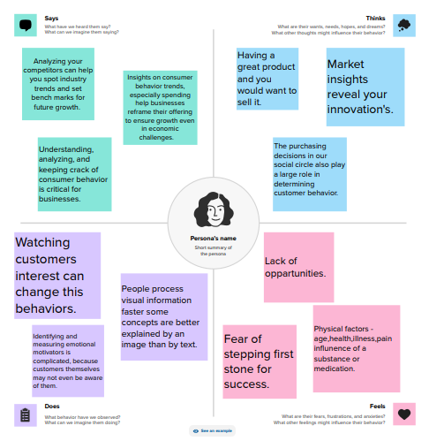

**2.2 Ideation & Brainstorming Map**

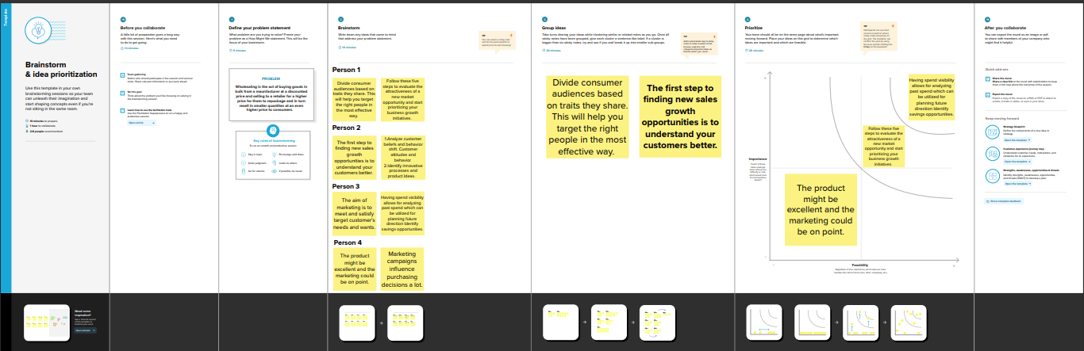

**3. RESULT**

**Visualisation**

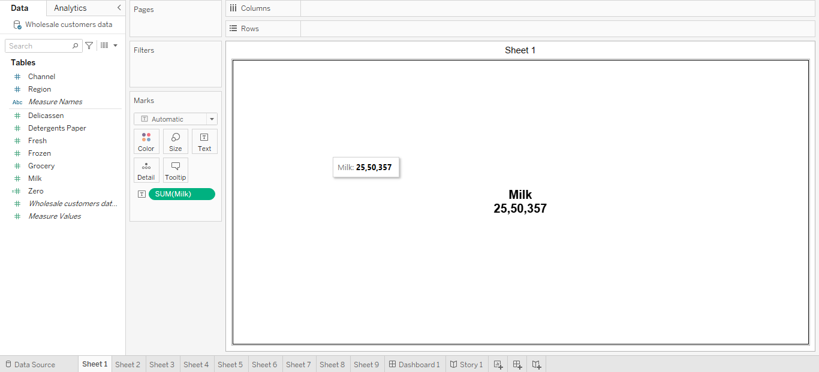

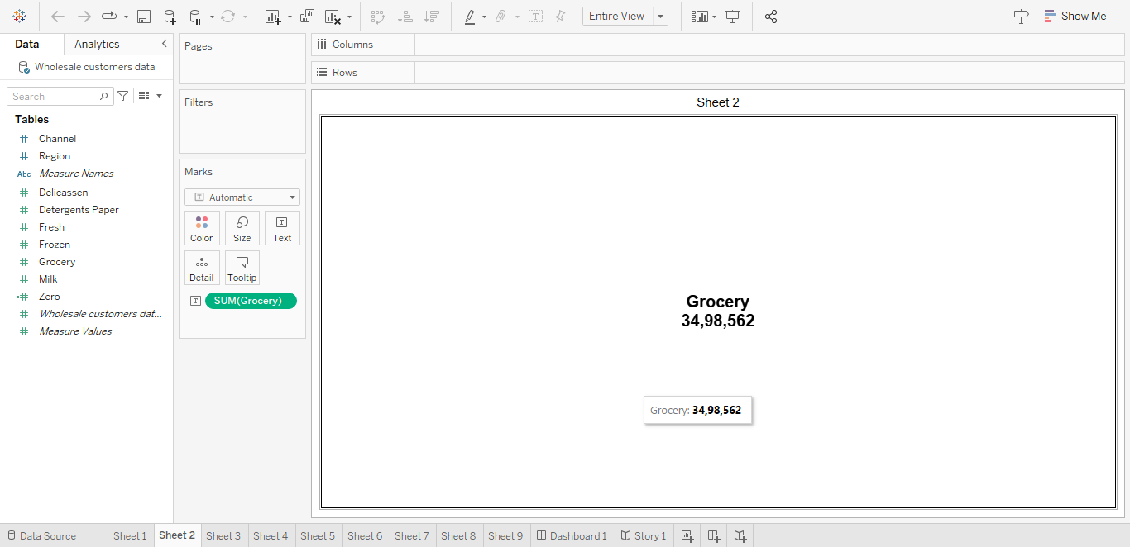

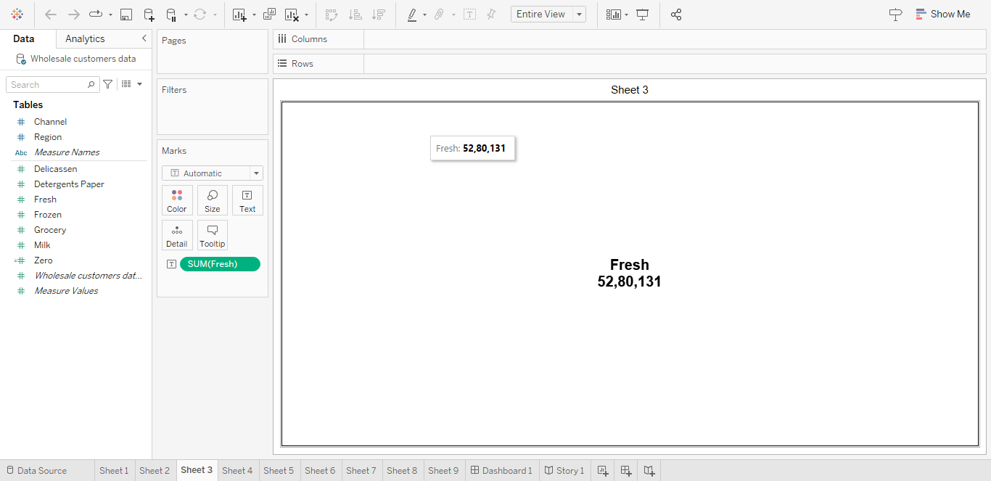

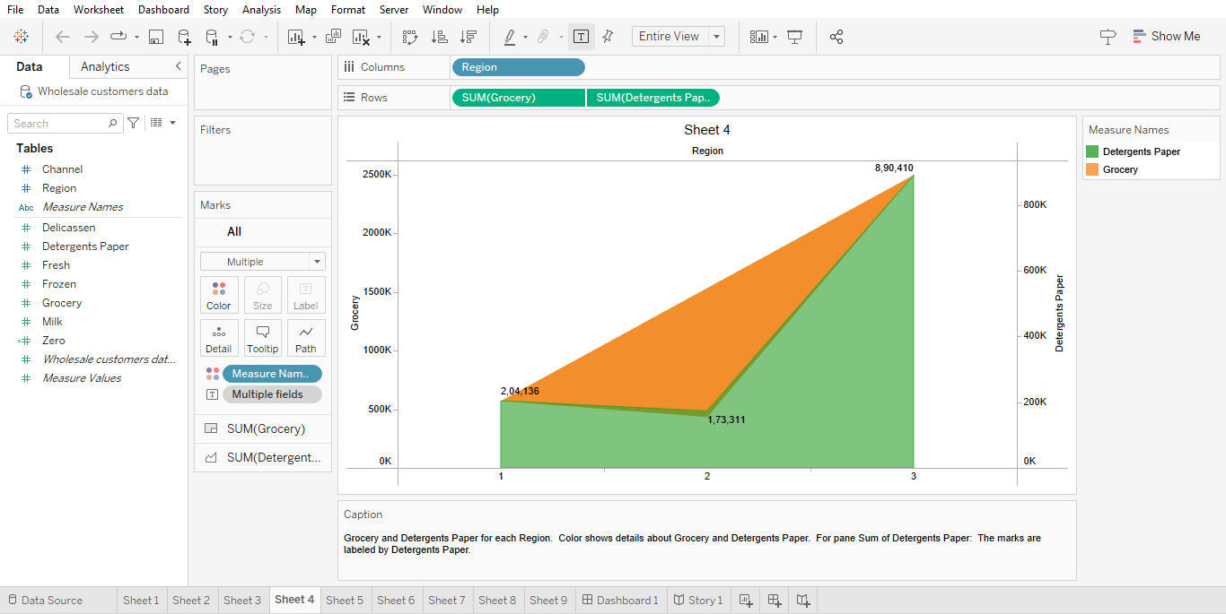

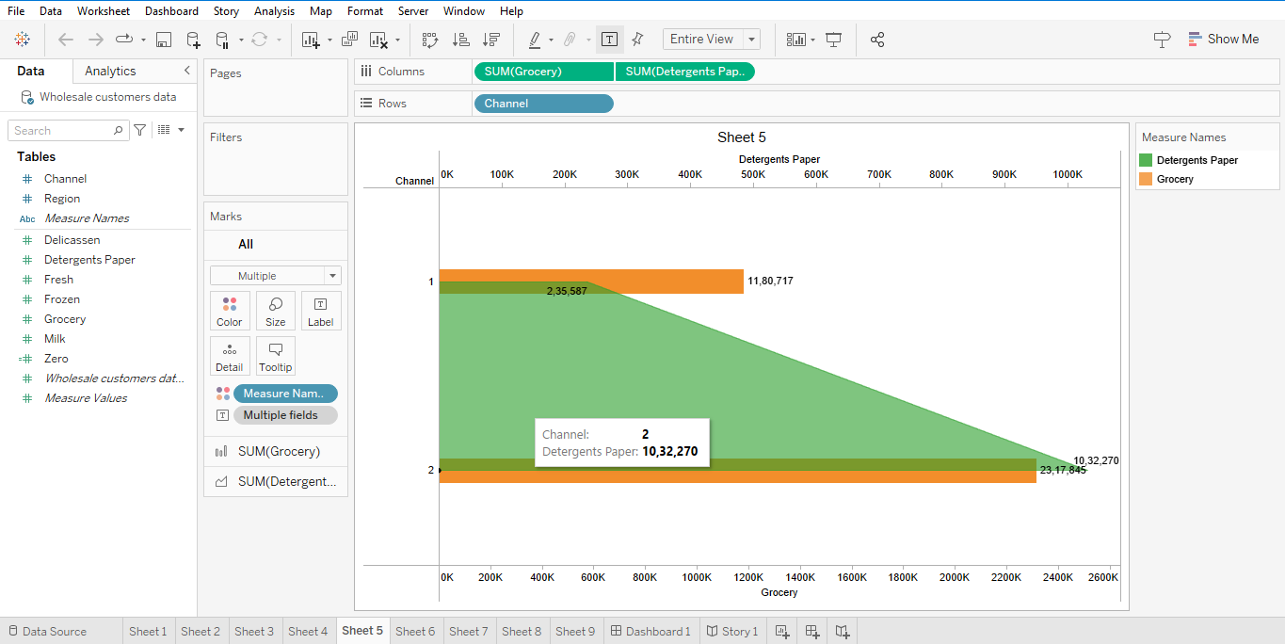

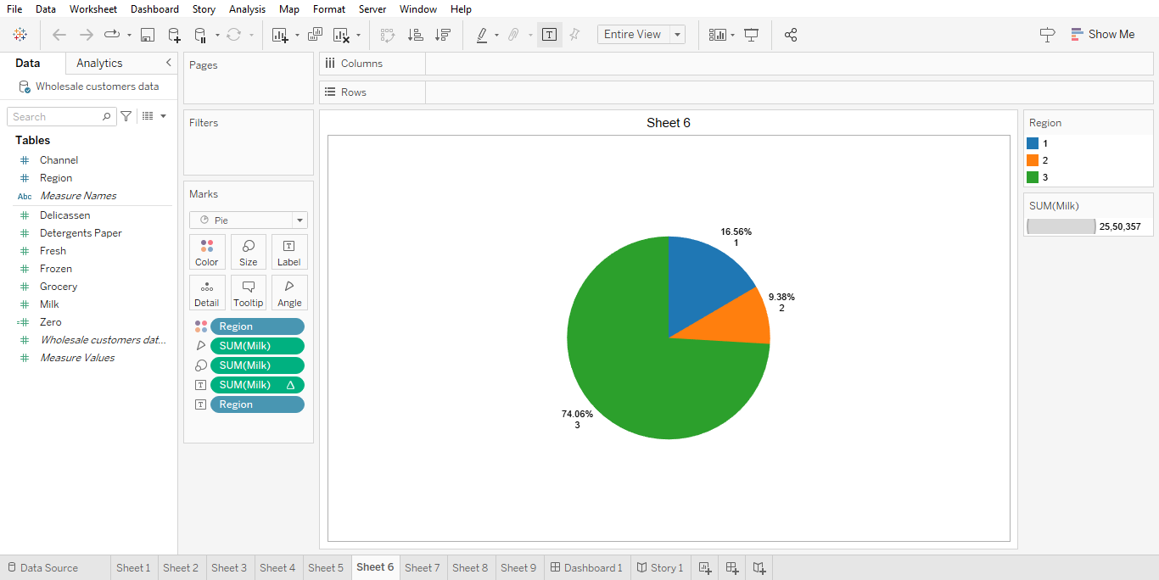

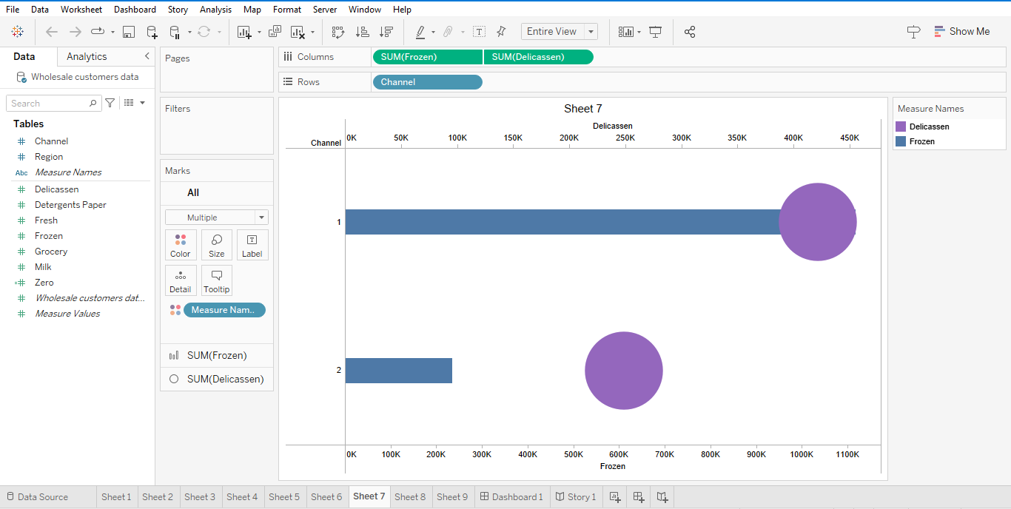

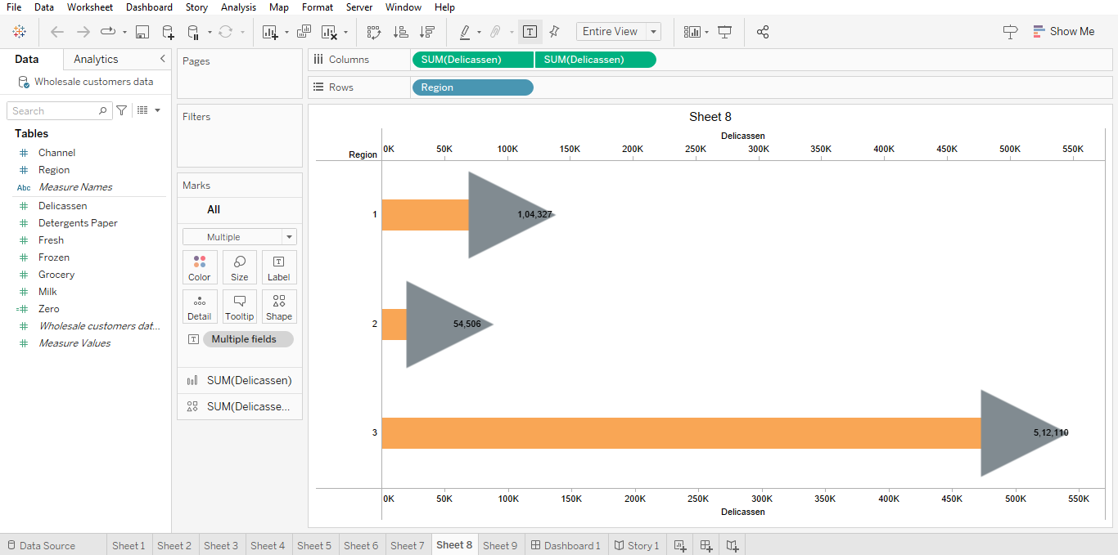

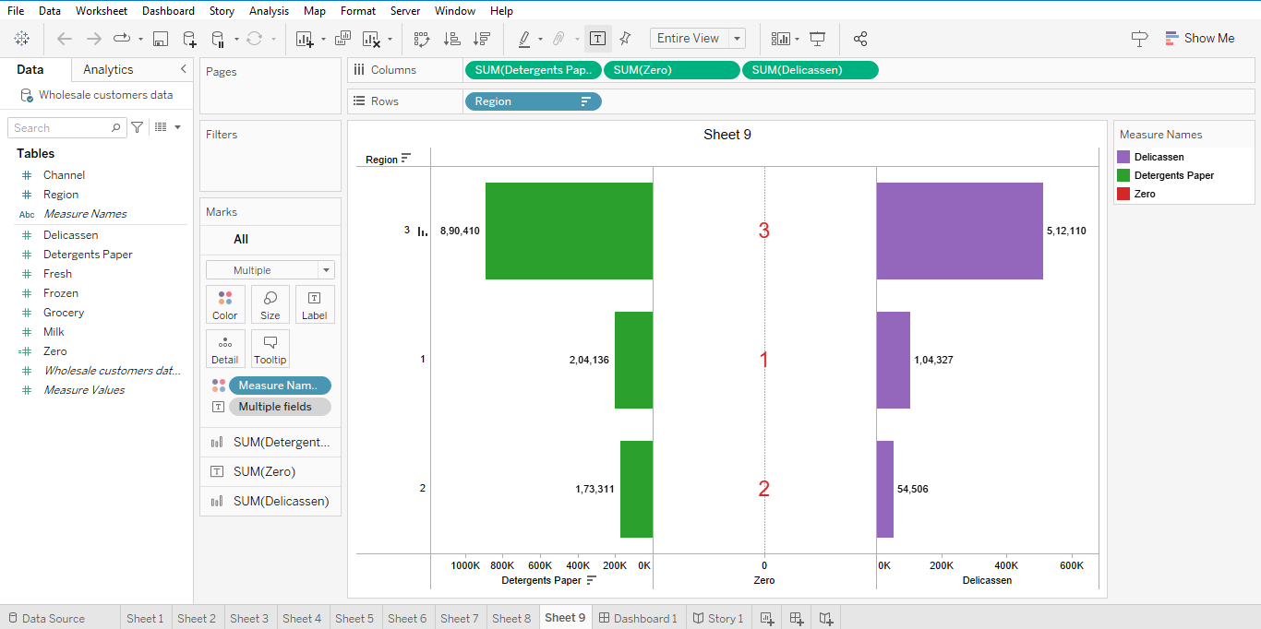

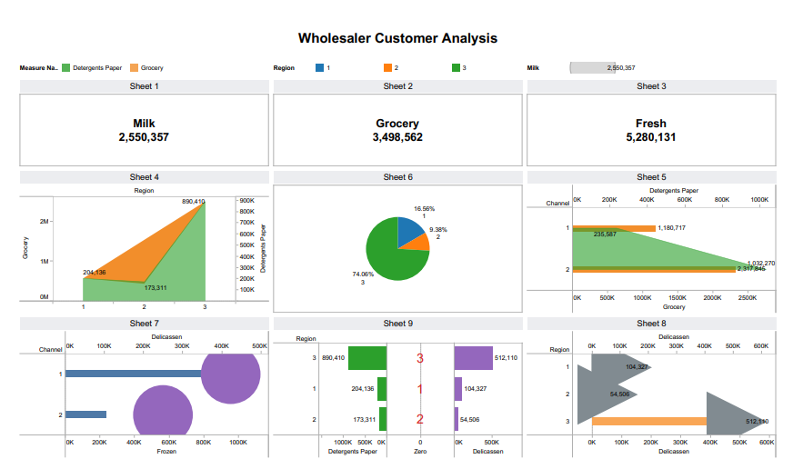

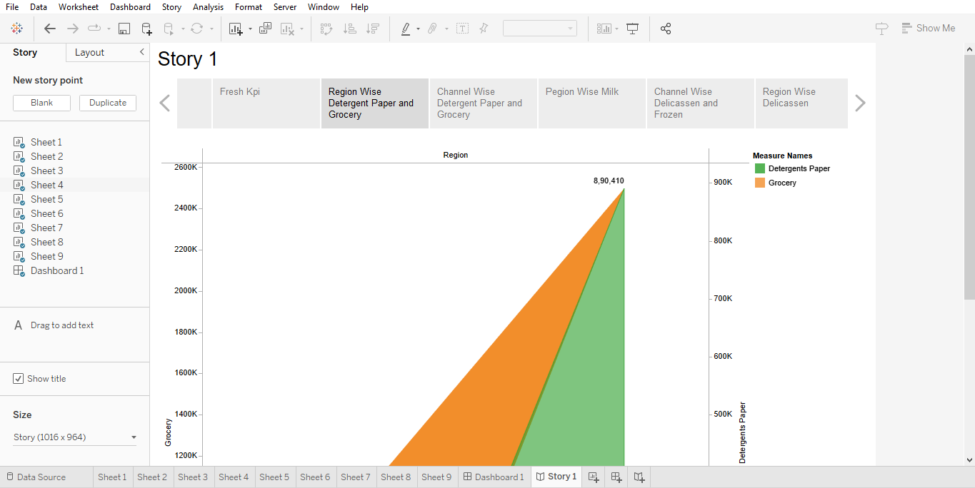

**4. ADVANTAGES & DISADVANTAGES**

**List of advantages and disadvantages of the proposed solution**

* For many businesses, growth signals success. It creates new opportunities, brings in more customers and generates greater profits.
* Weaknesses are disadvantages of the entrepreneur, which could include lack of knowledge or experience.
* No benefits of social media marketing list would be complete without talking about its access to paid advertising services.
* Growth can generate virtuous circles of prosperity and opportunity.

**5. APPLICATIONS**

**The areas where this solution can be applied**

* Begin by analyzing any sectors that could benefit from your offering. Understand that industry’s growth potential and the competition.
* Trend Analysis is a technique used to ermine and Predict movements of an item based on current and historical date.
* The SWOT analysis tool can be used to Identify and explore opportunities.
* Using the information given, conduct a market analysis that can be part of a larger feasibility study.

**6. CONCLUSION**

**Conclusion summarizing the entire work and findings**

* A SWOT analysis helps you identify strengths, weaknesses, opportunities, and threats for a specific project or your overall business plan.
* Analyze data and gather additional information to identify potential growth opportunities and understand the market dynamics.
* Identify the strengths, weaknesses, opportunities and threats that can affect the future of your business.

**7. FUTURE SCOPE**

**Enhancements that can be made in the future**

* Data analytics can also help organizations Identify opportunities to streamline operations, reduce costs, or maximize profits.
* The Global consumer Insights survey is a biannual study that seeks to keep a closer watch on changing consumer trends.
* The elements of value work best when a company’s leaders recognize them as a growth opportunity and make value of priority.

**\*\*\* (Thank you) \*\*\***